

**Bachy Soletanche UK – Secure Top Prize at International Safety Awards**



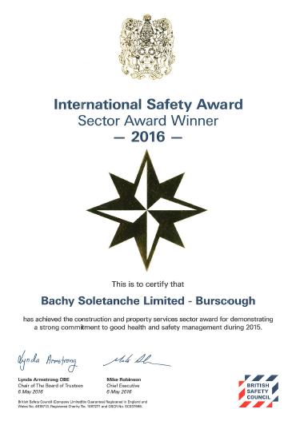This year Bachy Soletanche was one of the few companies to gain a distinction with full marks from their entry into the British Safety Council International Awards and were subsequently shortlisted in the Construction and Properties sector. Fifteen other leading world-wide construction companies also made this shortlist, providing stiff competition.

On 5 May 2016 at the British Safety Council Awards dinner at the Grosvenor House Hotel in London, Bachy Soletanche achieved the **ultimate prize of sector winners**. This award reflects the hard work by every employee within our business to improve the safety on our worksites, and hence ensuring the health and wellbeing of everyone associated with our work.

A total of 460 companies world-wide entered for the British Safety Council International Awards 2016. Applicants are judged on responses to questions covering every area of health, safety and wellbeing. In total 436 of the entries gained an award which ranged from a pass, merit or distinction.

To gain a distinction entrants had to attain an overall mark of above 98% and only 7% of companies managed to attain this level. These companies are then entered into their individual sector awards with the ultimate prize of sector winner announced on the night of the annual award.

To have reached where we are today, we have had to change our behaviours and the way we work and this is certainly not the end of this journey. Although our incident rates are at an all-time low we still have employees sustaining accidents and this can never be accepted.

By working together and continuing to change our behaviours we can continue on our journey to make our work areas safe, healthy and a place where people are proud to work.

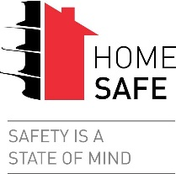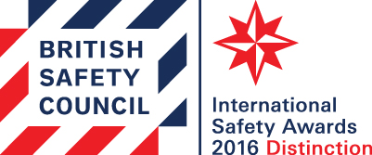

**Andrew Carpenter**

**Group SHEQ Director**

**Bachy Soletanche**